**BATCH NO :B9-3A5E**

**Submitted By : Ajith B**

**SMART HOME APPLIANCE FOR DOOR**

**Circuit Design**

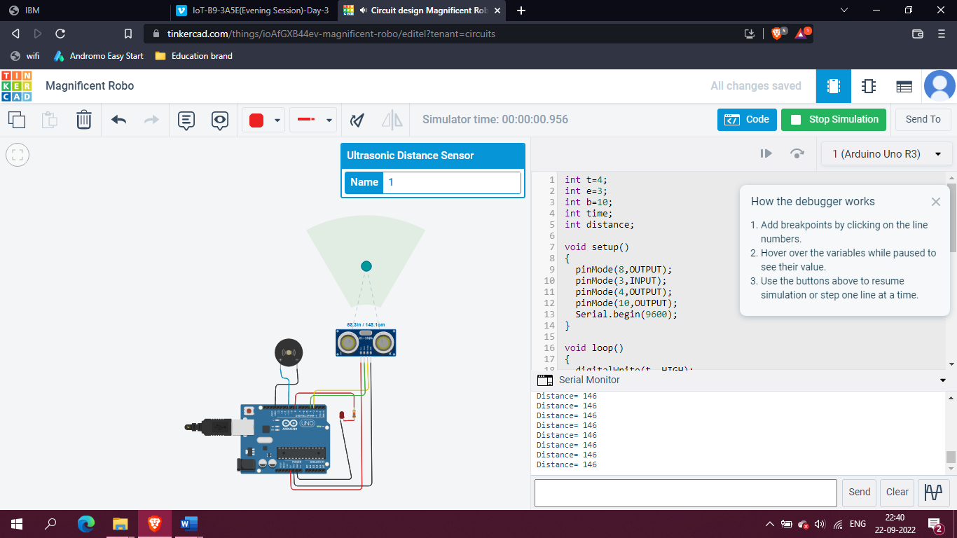

**Program:**

int t=4;

int e=3;

int b=10;

int time;

int distance;

void setup()

{

pinMode(8,OUTPUT);

pinMode(3,INPUT);

pinMode(4,OUTPUT);

pinMode(10,OUTPUT);

Serial.begin(9600);

}

void loop()

{

digitalWrite(t, HIGH);

delayMicroseconds(10);

digitalWrite(t, LOW);

delayMicroseconds(10);

time=pulseIn(e,HIGH);

distance=(time*0.034)/2;

if(distance<=100)

{

Serial.print("Distance= ");

Serial.println(distance);

digitalWrite(8,HIGH);

delay(10);

digitalWrite(10,LOW);

delay(10);

}

else

{

Serial.print("Distance= ");

Serial.println(distance);

digitalWrite(8,LOW);

delay(10);

digitalWrite(10,HIGH);

delay(10);

}

}